Lab - Week 7

PART A
(PART A: TO BE REFERRED BY STUDENTS)

Objective: Use AJAX to fetch and display data dynamically in a web application.

Theory:

AJAX (Asynchronous JavaScript and XML) is a technique for creating dynamic and fast web pages by allowing data exchange with a server in the background. AJAX enables updating parts of a webpage without reloading the entire page, providing a smoother user experience. In this lab, we will use AJAX to fetch data from a public API and display it in a structured HTML table.

Key Concepts:
- AJAX Requests: Using XMLHttpRequest or modern fetch() API to communicate with a server asynchronously.
- Public APIs: APIs that provide open access to data (e.g., weather, user details, news).
- Dynamic Content Rendering: Displaying fetched data in a formatted table using JavaScript.
- Error Handling: Managing failed requests and displaying appropriate error messages.

PART B
(PART B: TO BE COMPLETED BY STUDENTS)
Students must submit the soft copy as per following segments within two hours of the practical. The soft copy must be uploaded on the portal at the end of the practical. The filename should be AWT_batch_rollno_experimentno Example: AWT_A1_A001_P1

Roll No.: A006 | Name: AKSH SONI
Prog/Yr/Sem: MCA | Batch: B1
Date of Experiment: 16/03/2026 | Date of Submission: 16/03/2026

Task 1: Fetch Data from a Local JSON File

- Set up the Project Structure:
Create a folder structure:
ajax-local-demo/
├─ index.html # Main HTML file with UI elements
├─ app.js # JavaScript file with AJAX code
└─ data.json # Local JSON data file
- Write the AJAX Request for JSON:
  - Use XMLHttpRequest or fetch() to load data.json.
  - Parse the JSON data and display it dynamically in a styled HTML table.
  - Include columns like Name, Age, and City.
- Sample JSON Data (data.json):
[
{"name": "Rahul", "age": 21, "city": "Mumbai"},
{"name": "Anjali", "age": 22, "city": "Pune"},
{"name": "Amit", "age": 25, "city": "Delhi"}
]

Fetch Data from a Local XML File

- Add an XML File to the Project:
  - Update the project structure to include data.xml. ajax-local-demo/
├─ index.html
├─ app.js
├─ data.json
└─ data.xml
# Main HTML file with UI elements
# JavaScript file with AJAX code # Local JSON data file
# Local XML data file

Sample XML Data (data.xml):
<?xml version="1.0" encoding="UTF-8"?>
<students>

<student>
<name>John Doe</name>
<age>22</age>
</student>
<student>
<name>Jane Smith</name>
<age>24</age>
</student>
<student>
<name>Mike Johnson</name>
<age>20</age>
</student>
</students>
Write the AJAX Request for XML:
  - Load data.xml using XMLHttpRequest.
  - Parse the XML response and display student names and ages in an HTML table.

Deliverables:
  - Functional HTML page with AJAX data fetching from local files.
  - Dynamic rendering of JSON and XML data in a styled table.

Submission Checklist:
  - Source code with appropriate comments.
  - Screenshot of the application in the browser.
  - Explanation of how AJAX was used to fetch data from local files.

Expected Learning Outcomes:

By the end of this practical, students will be able to:
  - Use AJAX to fetch data asynchronously from local JSON and XML files.
  - Dynamically display data in a structured format using JavaScript.
  - Implement error handling for robust web applications.

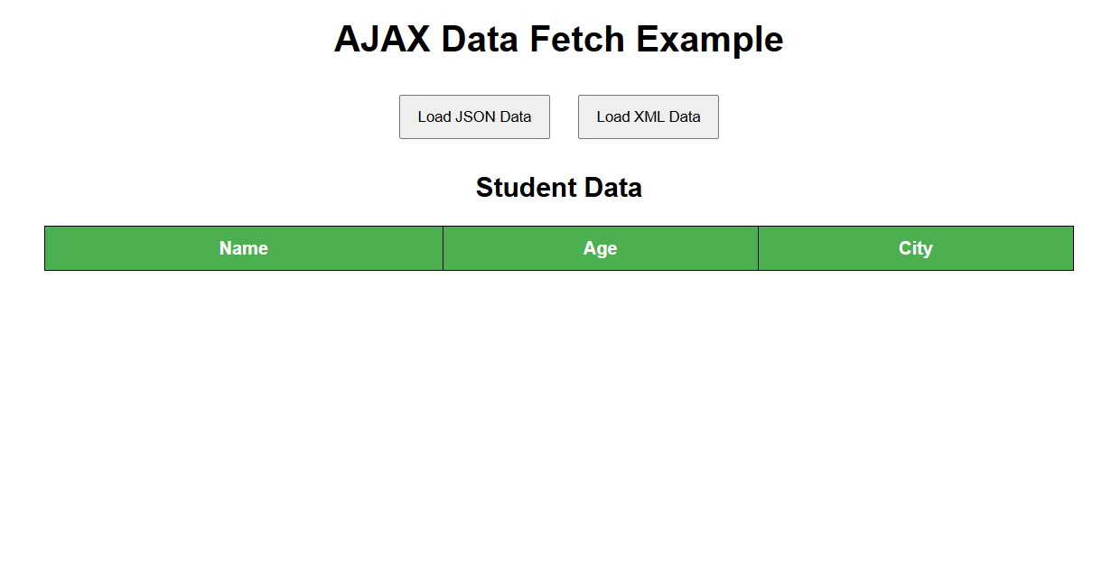
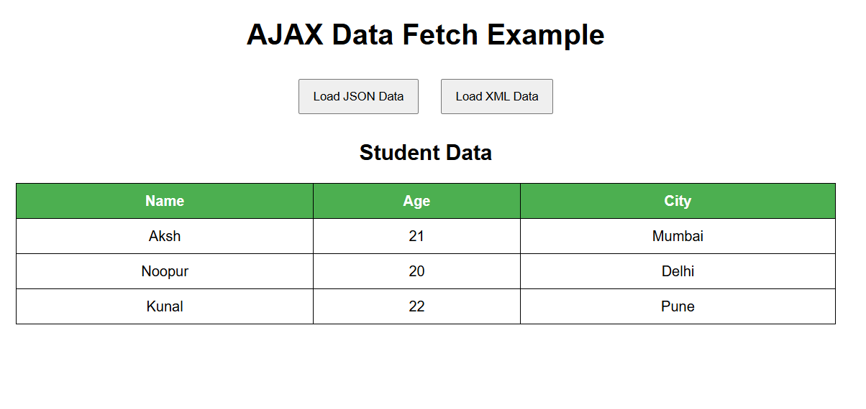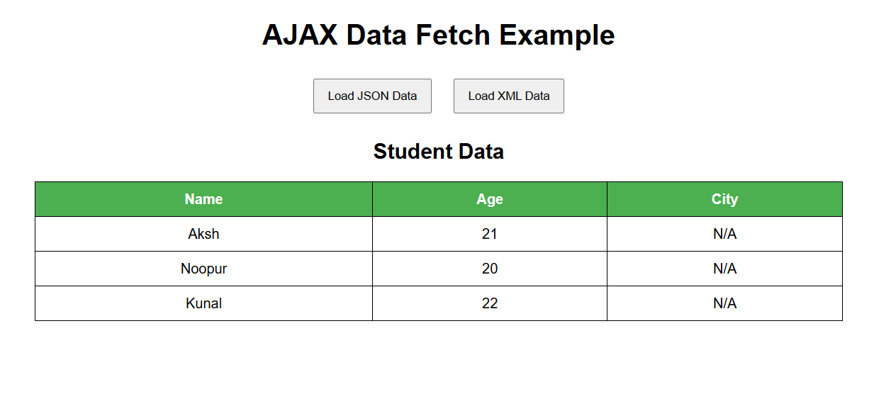

Index.html
<!DOCTYPE html>
<html>
<head>
<title>AJAX Local File Demo</title>
<link rel="stylesheet" href="style.css">
</head>

<body>

<h1>AJAX Data Fetch Example</h1>

<button onclick="loadJSON()">Load JSON Data</button>
<button onclick="loadXML()">Load XML Data</button>

<h2>Student Data</h2>

<table border="1" id="dataTable">
<thead>
<tr>
<th>Name</th>
<th>Age</th>
<th>City</th>
</tr>
</thead>
<tbody></tbody>
</table>

<script src="script.js"></script>

</body>
</html>

Style.css
body{
font-family: Arial;
text-align: center;
}

table{
margin: auto;
border-collapse: collapse;
width: 60%;
}

th, td{
padding: 10px;
border: 1px solid black;
}

th{
background-color: #4CAF50;
color: white;
}

button{
padding: 10px 15px;
margin: 10px;
cursor: pointer;
}

Data.json
{
"students": [
{
"name": "Aksh",
"age": 21,
"city": "Mumbai"
},
{
"name": "Noopur",
"age": 20,
"city": "Delhi"
},
{
"name": "Kunal",
"age": 22,
"city": "Pune"
}
]
}

Data.xml
<?xml version="1.0" encoding="UTF-8"?>
<students>
<student>
<name>Aksh</name>
<age>21</age>
</student>

<student>
<name>Noopur</name>
<age>20</age>
</student>

<student>
<name>Kunal</name>
<age>22</age>
</student>
</students>

Script.js
// Fetch JSON data using fetch API
function loadJSON() {

fetch("data.json")
.then(response => response.json())
.then(data => {

let table = document.querySelector("#dataTable tbody");
table.innerHTML = "";

data.students.forEach(student => {

let row = `
<tr>
<td>${student.name}</td>
<td>${student.age}</td>
<td>${student.city}</td>
</tr>
`;

table.innerHTML += row;
});

})
.catch(error => {
alert("Error loading JSON data");
console.log(error);
});
}

// Fetch XML data using XMLHttpRequest
function loadXML() {

let xhr = new XMLHttpRequest();

xhr.onreadystatechange = function () {

if (this.readyState == 4 && this.status == 200) {

let xmlDoc = this.responseXML;
let students = xmlDoc.getElementsByTagName("student");

let table = document.querySelector("#dataTable tbody");
table.innerHTML = "";

for (let i = 0; i < students.length; i++) {

let name = students[i].getElementsByTagName("name")[0].textContent;
let age = students[i].getElementsByTagName("age")[0].textContent;

let row = `
<tr>
<td>${name}</td>
<td>${age}</td>
<td>N/A</td>
</tr>
`;

table.innerHTML += row;
}
}
};

xhr.open("GET", "data.xml", true);
xhr.send();
}

